-1. Create a virtual environment

2. Install Django using pip command

pip install django / python -m pip install django

3. create project

django-admin startproject meeting_planner

4. Move into the project directory

cd meeting_planner

5. Run the development server

python manage.py runserver

5.1 you can stop the server with command

Ctrl+C

------------------------------------------------------------------------------------------------------------

####################################

# Create a web page #

# Create a Django app #

# Add a view function #

# Assign a URL #

# Run and view the page #

####################################

1. Create new App

python manage.py startapp website

(at the memoment it will create multiple files)

2. Add your application into settings.py in core folder

add your application name into INSTALLED_APPS

eg: ['django.contrib.staticsfiles',

'website',]

comma is important after the application

3. Open views.py

import package

from django.http import HttpResponse

create a welcome function

def welcome(request):

return HttpResponse("welcome to the meeting)

4. open urls.py

import your viws.py file function

from website.views import welcome

add your path in urlpatterns

eg: urlpatterns = [

path("admin/", admin.site.urls),

path("Welcome.html',welcome),

]

# Welcome.html is an url

# welcome is an actual function

Now run the server

python manage.py runserver

LETS add some more methods into views.py

import datetime module

from datetime import datetime

add new method date

def date(request):

return HttpResponse("this page was served at" + str(datetime.now()))

lets add this function into urls.py

import your views.py file function

from website.views import welcome,date

add your path in urlpatterns

eg: urlpatterns = [

path("admin/", admin.site.urls),

path("Welcome.html",welcome),

path("date",date), #note here we not using .html

]

# note if you want make any page as Index page(first page user see when server is started)

add path as path("",function_name)

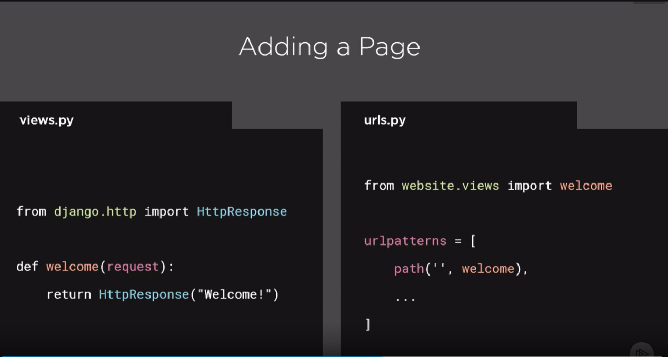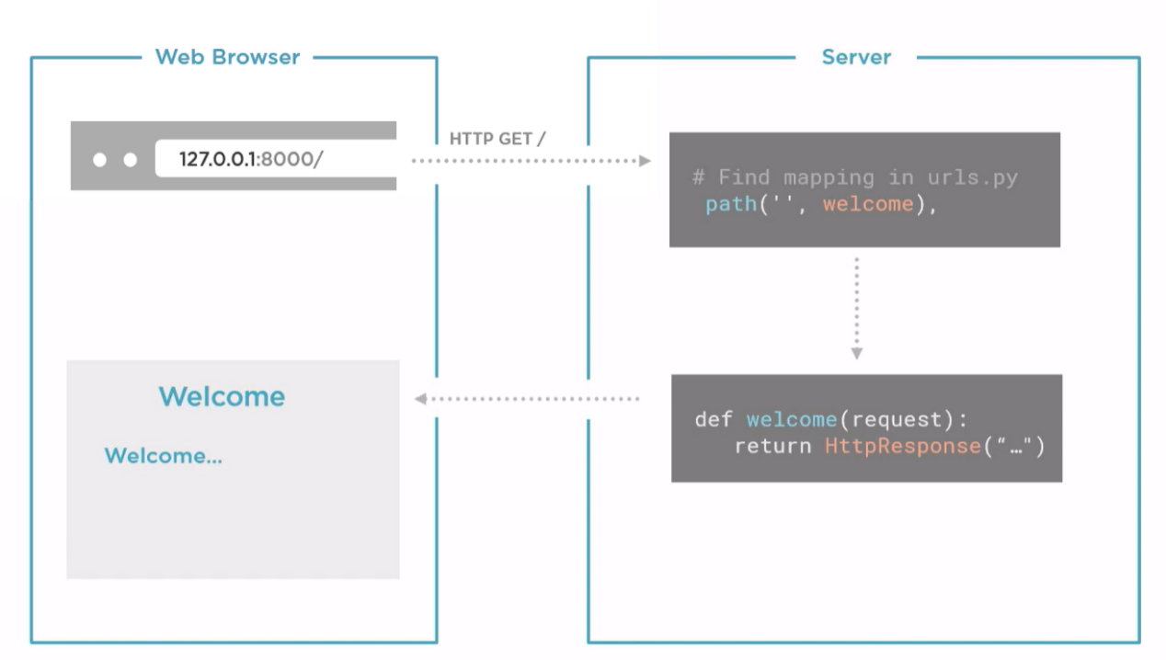

**Data Model:**

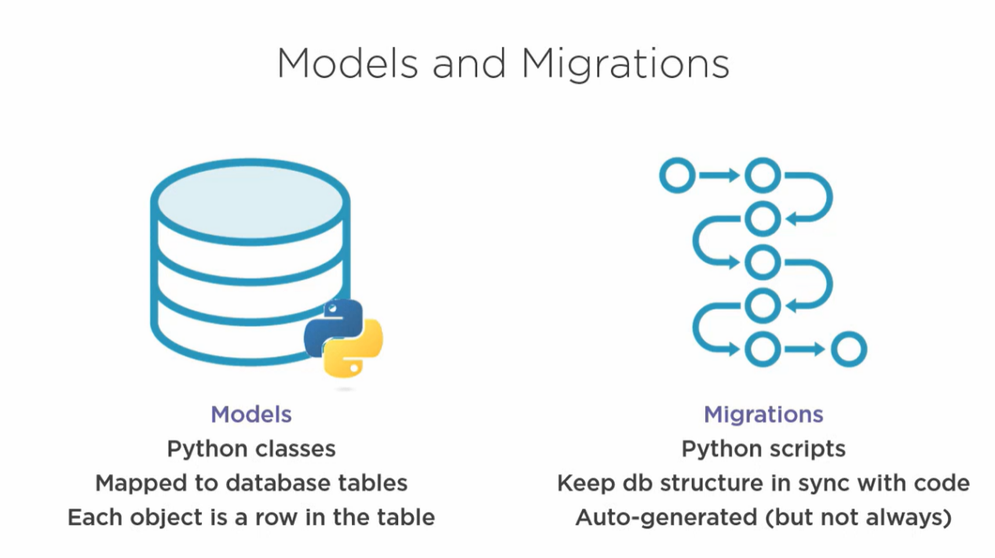

python manage.py showmigrations

Help to view the list migrations need to be done:

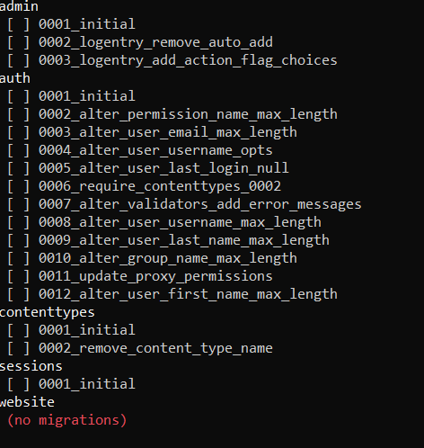

Once you check initially you can view this…

To Make all these migrate all this:

python manage.py migrate

To make connection with db use command:

python manage.py dbshell

( note: for that you need to install SQLite)

The result will like this.

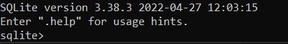

To check the tables in database

sqlite> .tables

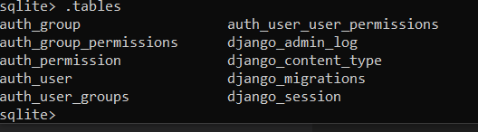

To check the migration details:

sqlite> select * from django_migrations;

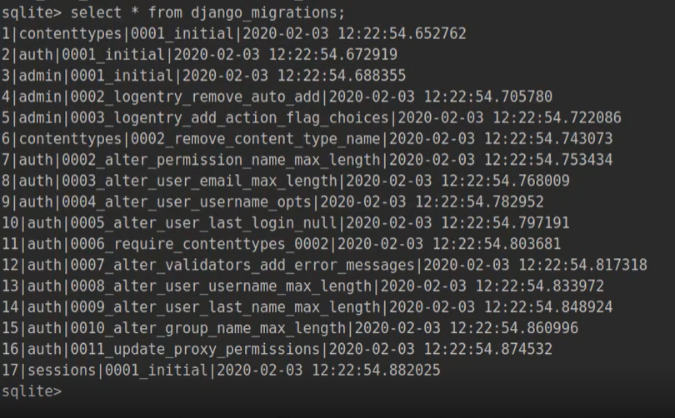

To EXIT the sql shell :

sqlite> .exit

**Create a MODEL:**

Lets create a new app called **meetings**:

python manage.py startapp meetings

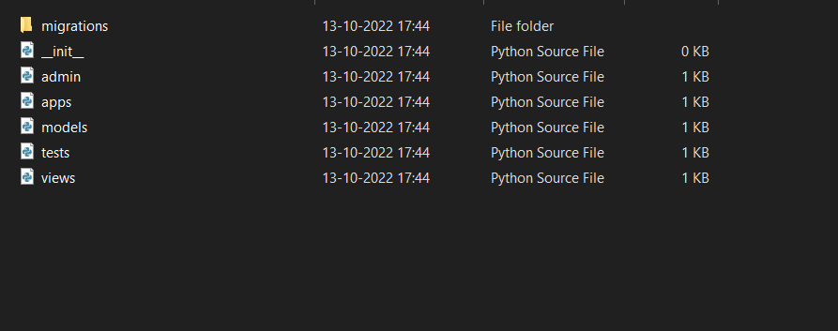

Folder will created.

Add the application in **Meeting_planner-->settings.py**

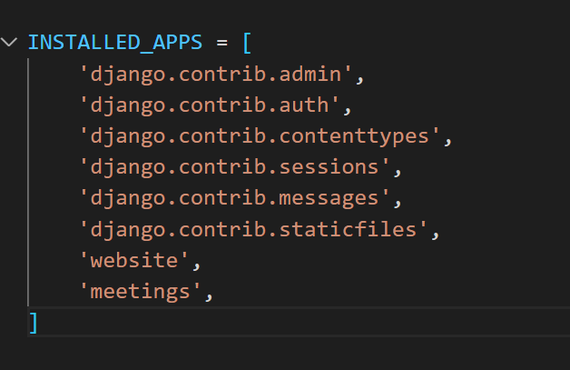

In **models.py** file written the model class:

class Meeting(models.Model): # models.Model was an base class which we inherited

Title = models.CharField(max_length = 200)

Date = models.DateField()

Once it done make the migration:

By using command python manage.py makemigrations

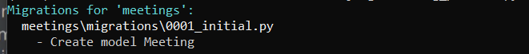

Now you can new file is created in meeting-->migrations folder

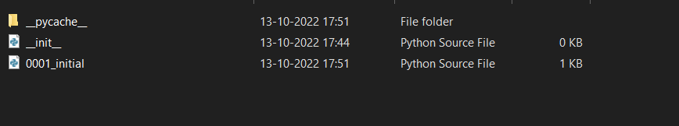

File content

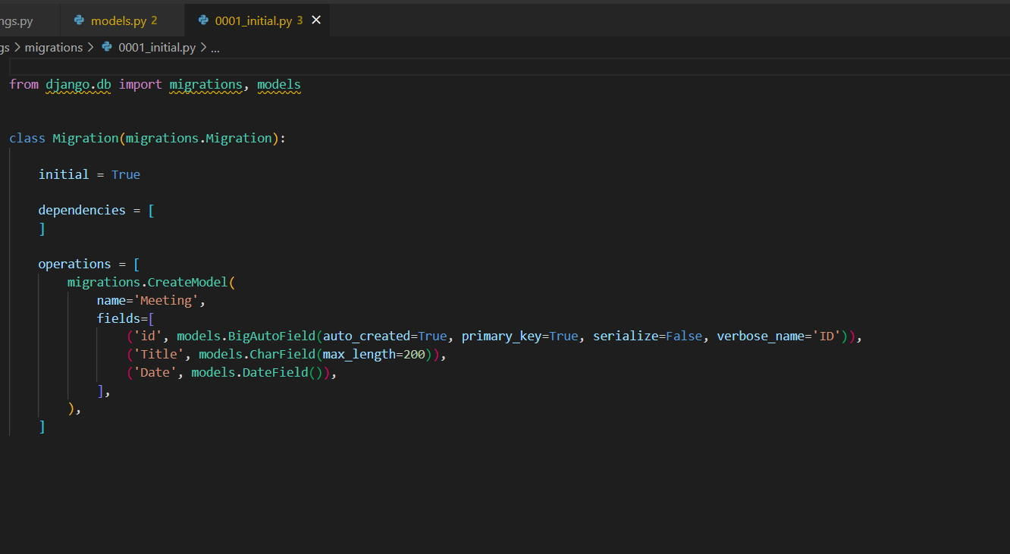

Now we need to migrate this to our project:

Now run the command:

python manage.py sqlmigrate meetings 0001 # either you can gave entire name or number is enough.

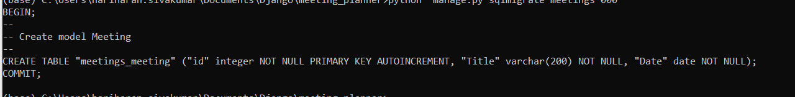

The model is created now we need to migrate this

python manage.py migrate

now you can see the changes will done

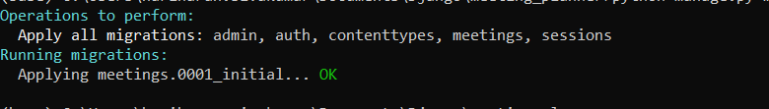

Now try to view the tables

python manage.py dbshell

sqlite> .tables

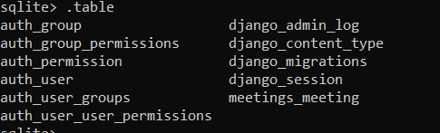

Now we can see our meetings table. Note table having a prefix of our app(meetings)

+

ADMIN:

Lets add some admin controls:

Lets dive to **meetings--> admin.py**

Add our model into **admin.py** file

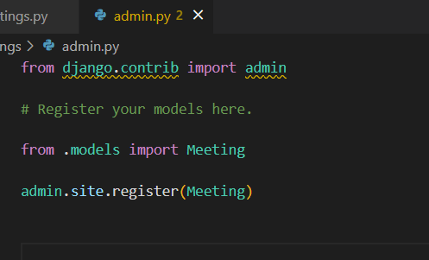

After this run the server and you can admin page to access that we need login username and password.

Lets create login username and password

python manage.py createsuperuser

Enter the username, mailid, password

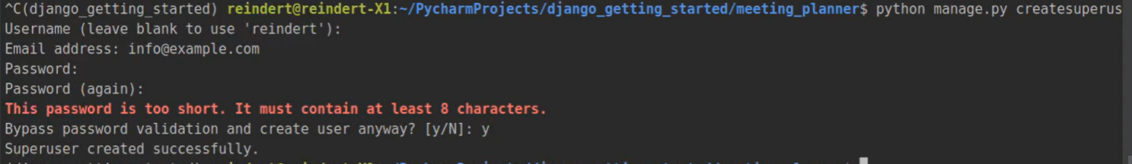

Now run the server and enter the password and username

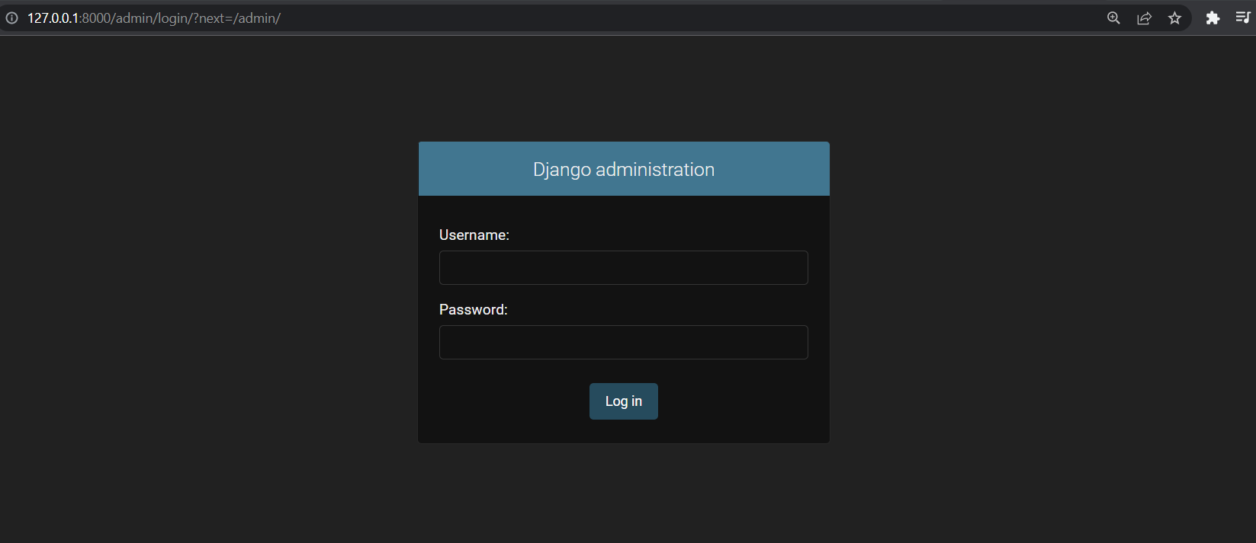

Once you logged in you access the database tables(python classes)

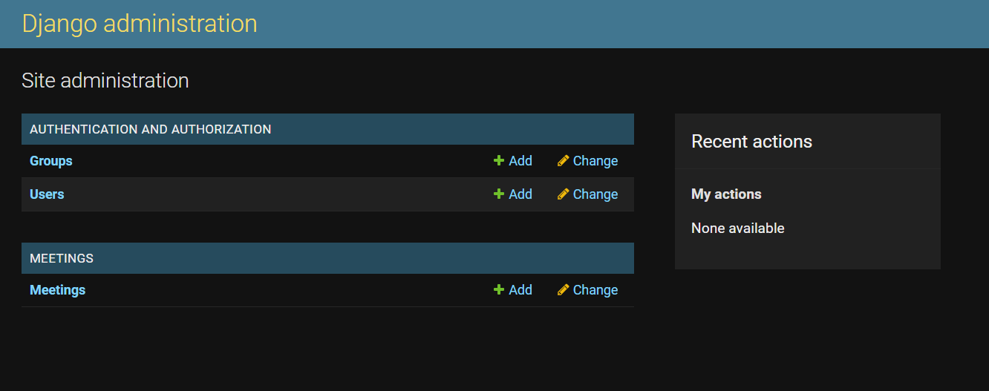

Click Add on meeting to enter the values.

The Django having built in features to build basic web HTML pages. It will helps work.

Eg:

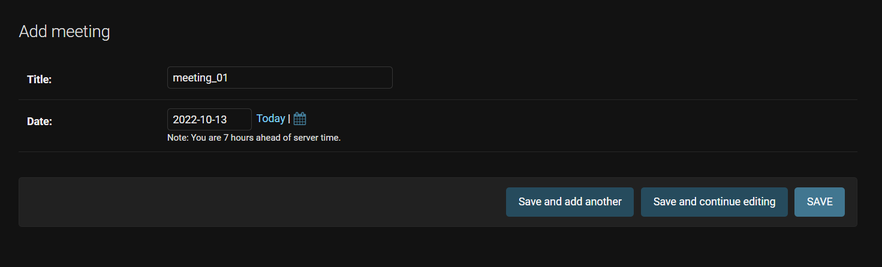

Enter the necessary details and choose any of save options. Once you done you can see result like

This.

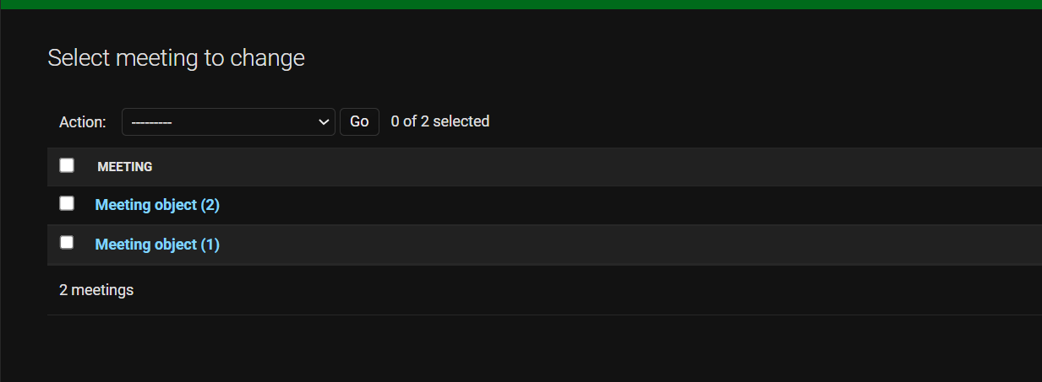

1. , (2) are unique Id’s.

(note: this is not for user purpose)

REVIEW:

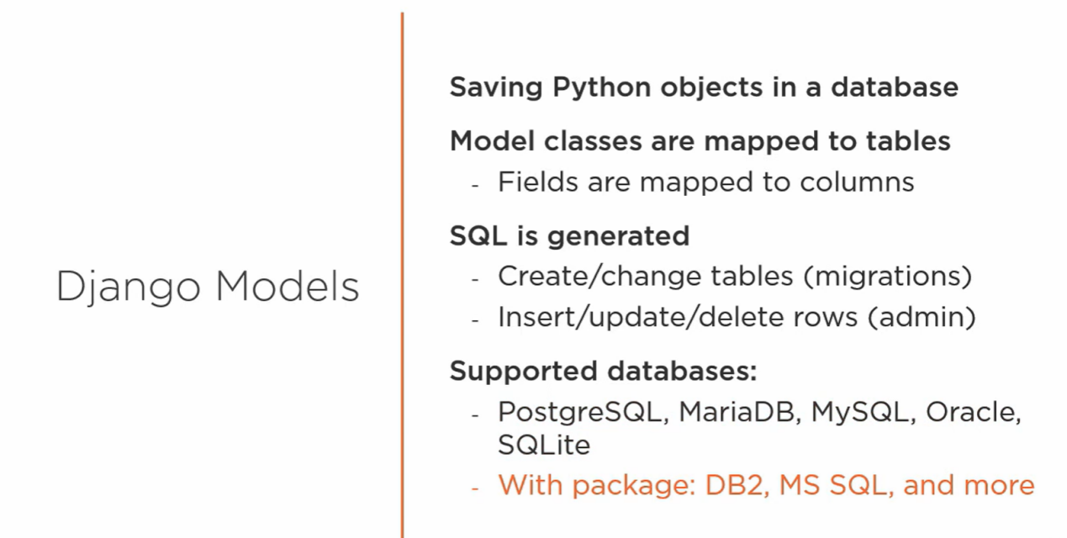

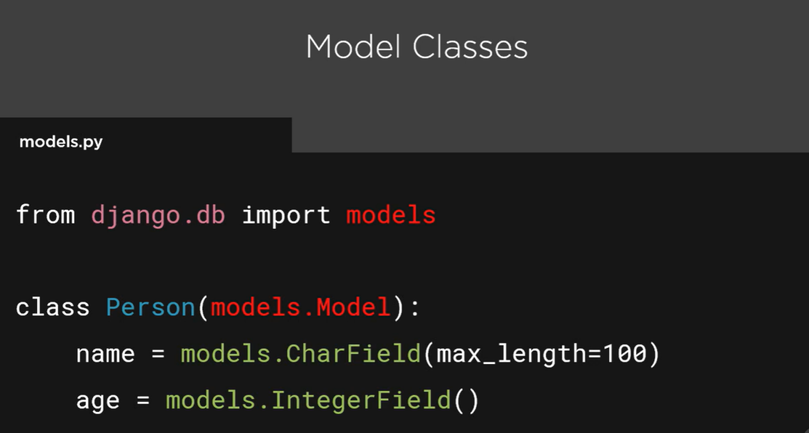

[More django model : visit <https://docs.djangoproject.com/en/4.1/ref/models/fields/> ]

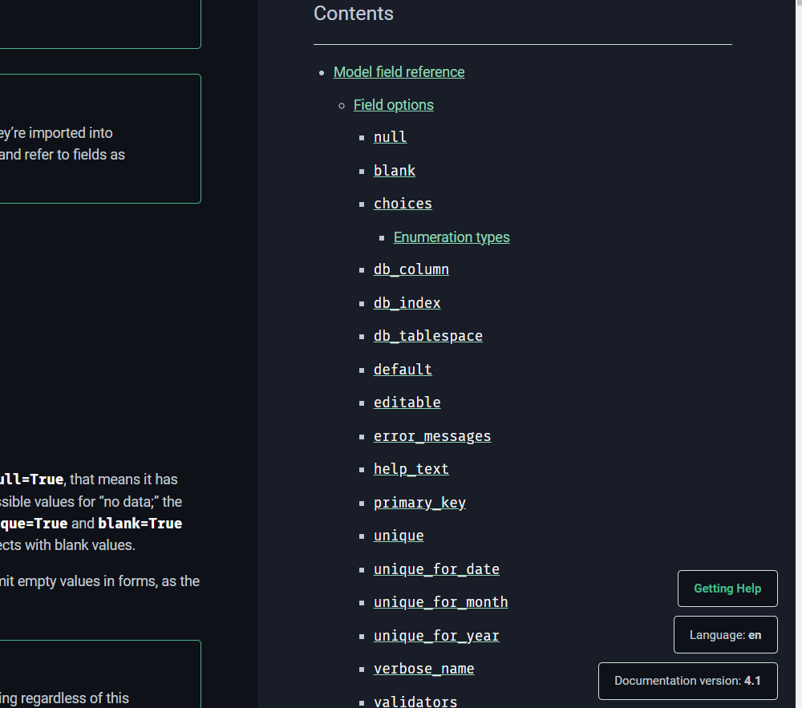

[ you can see multiple model in right side of the page ]

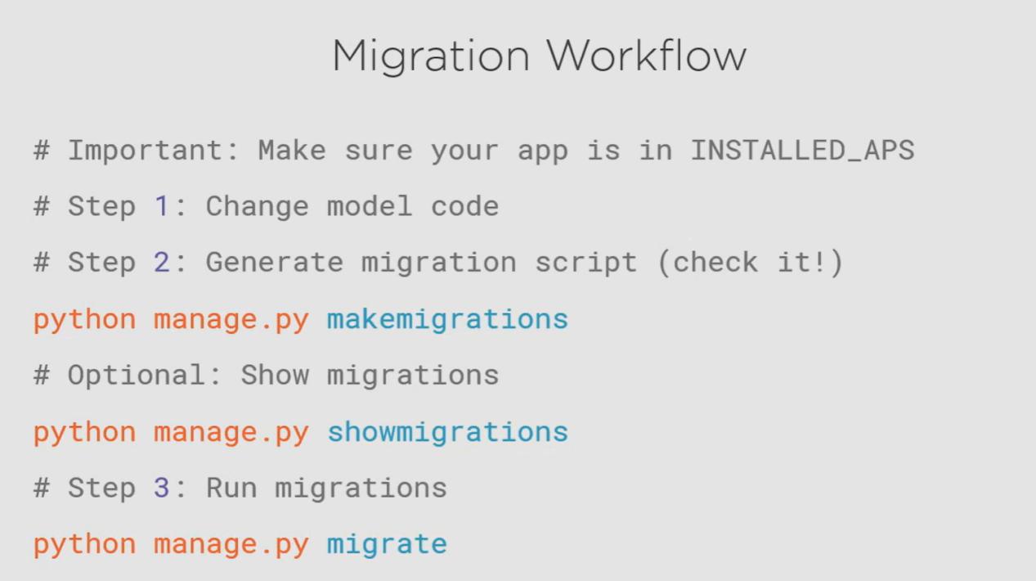

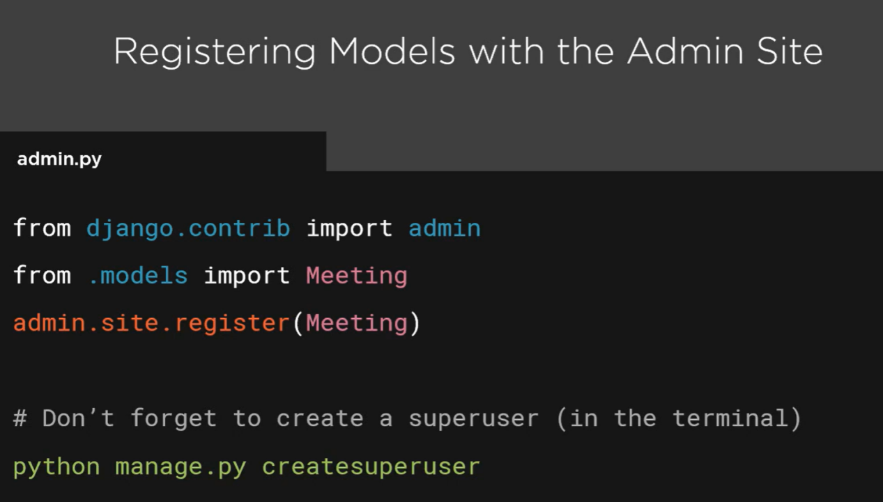

LETS BRING IT ALL TOGETHER:

- WORKFLOW

-ADD ANOTHER MODEL

-ADD FOREIGN KEY

Lets jump into **meetings--> migrations--> models.py**

Try to add:

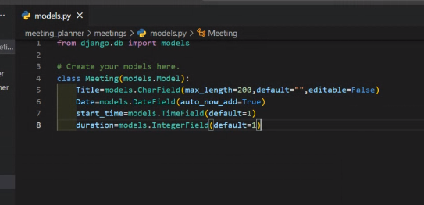

And make the migration python manage.py makemigrations

While doing this you can see the message like

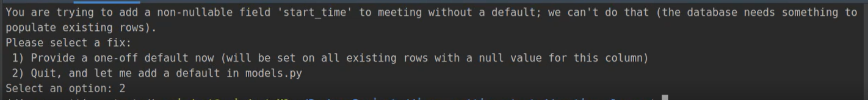

Because in data model already we are having data.

So let add default value on two new data fields:

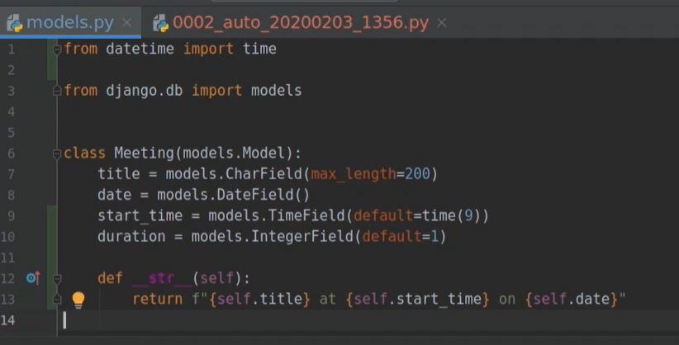

(note : __str__ spl method will return the string as a head)

And now make the migrations:

python manage.py makemigrations

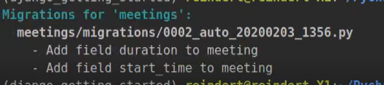

After the migration you can see new fields were added in meeting--> migrations-->0002___.py

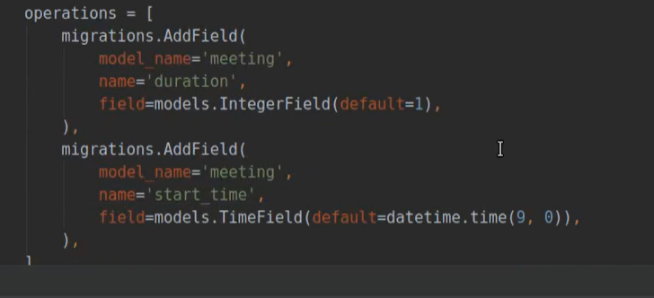

Add fields in admin**.py** to access the database.

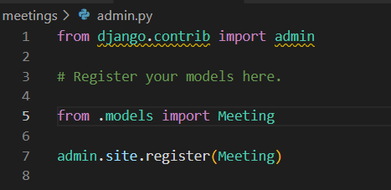

Now run the **python manage.py migrate**

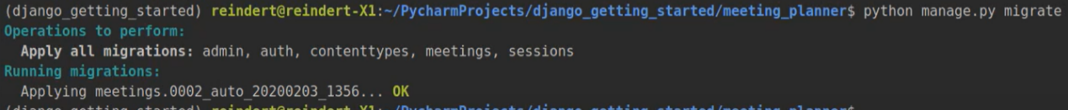

Now run the server

**Python manage.py runserver**

Enter the password and select the meetings.

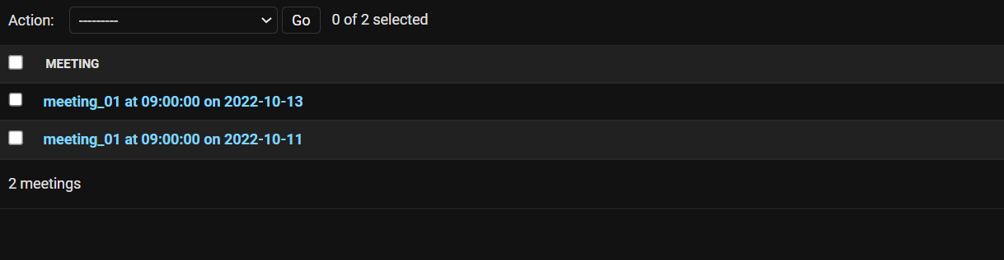

We can see the name was change .

Click on first one.

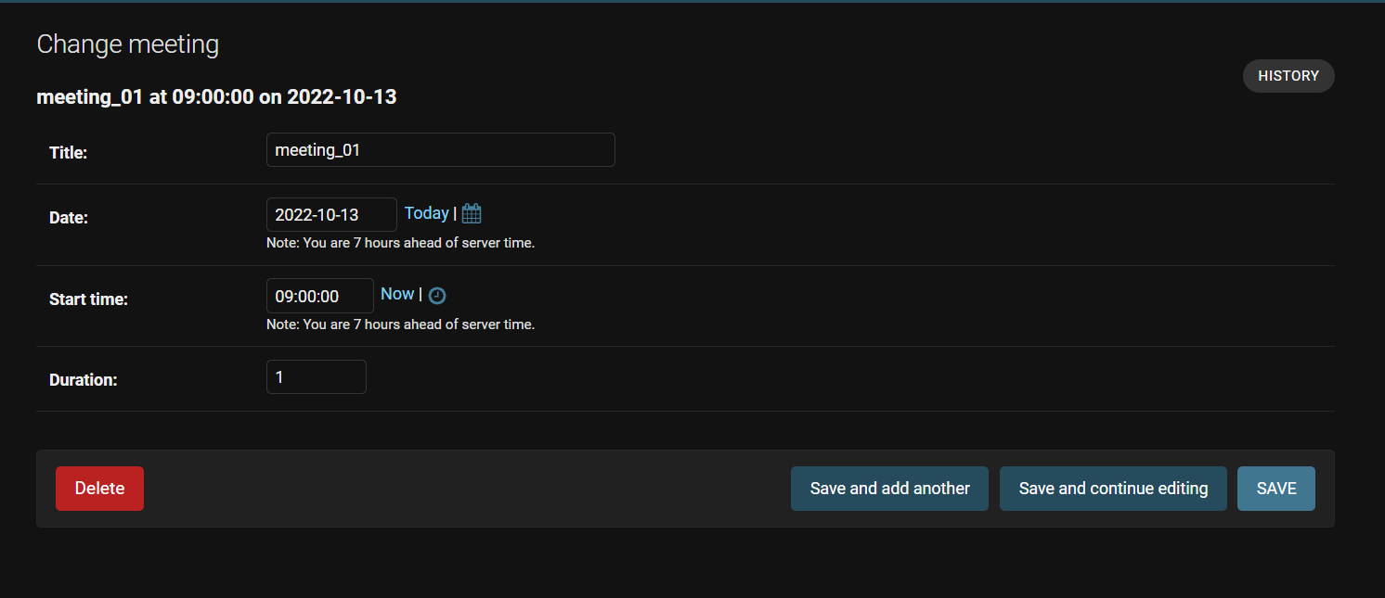

You can see the fields are changed.

#Lets create a new Model class called Room

#To represent the meeting room

#A room has a name, floor name, room number

Let create model under **meetings--> model.py**

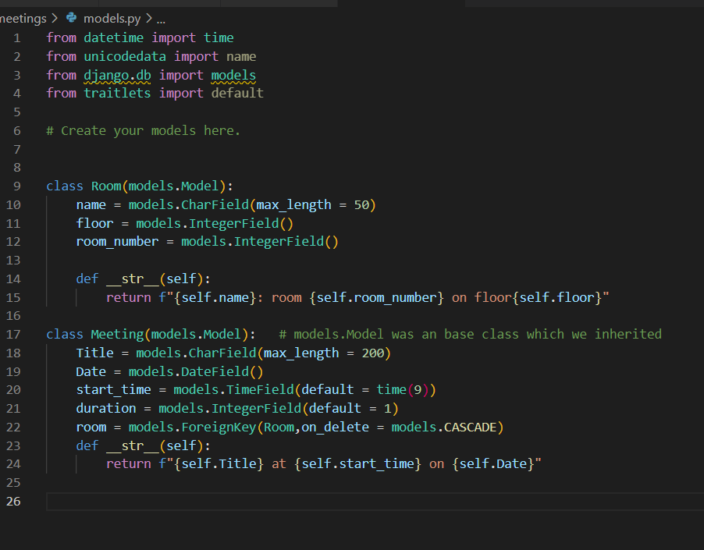

And now make the migrations:

python manage.py makemigrations



OMG.. now again we’re getting the same error to avoid this lets delete the files in migrations folder exculding **__init__.py** (don’t delete this) also delete db.sqlite3

After all this start the migrations:

python manage.py makemigrations

After the migration you can see new fields were added in **meeting--> migrations-->0001___.py**

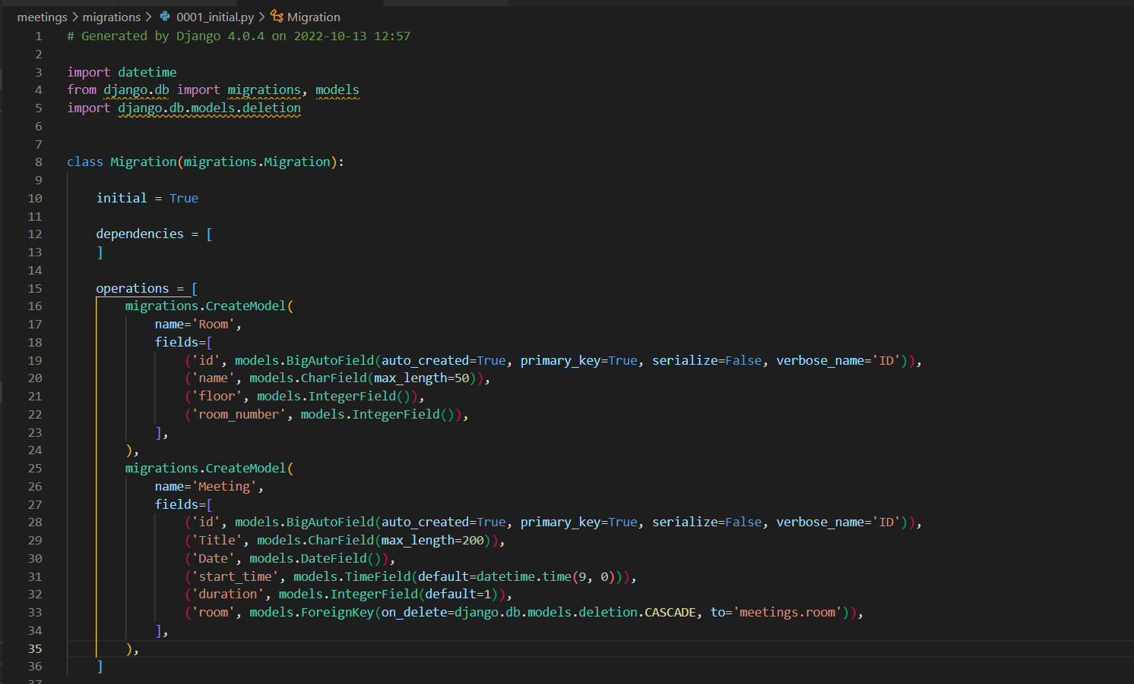

Make changes in **admin.py**

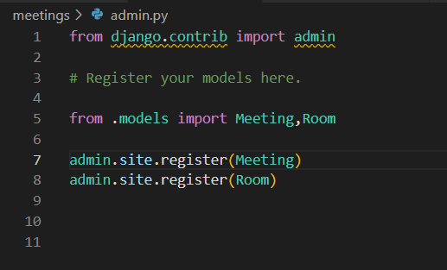

Now run the python manage.py migrate

And the server also using python manage.py runserver

After login into the application you can see the site like below

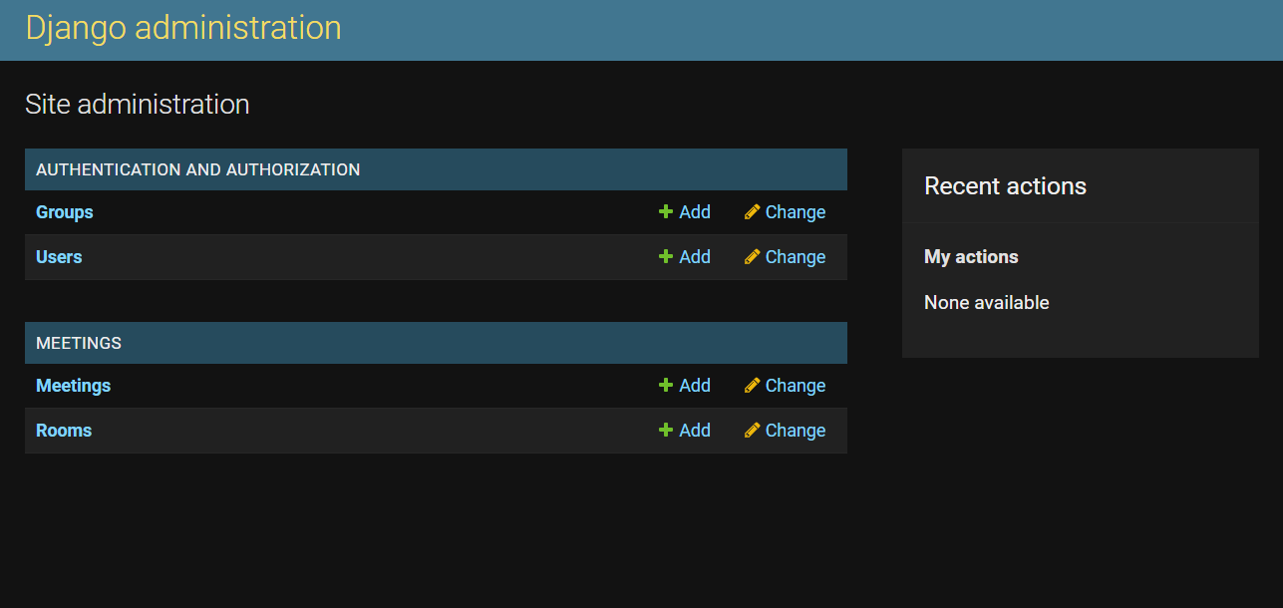

Click on meeting and add the values.

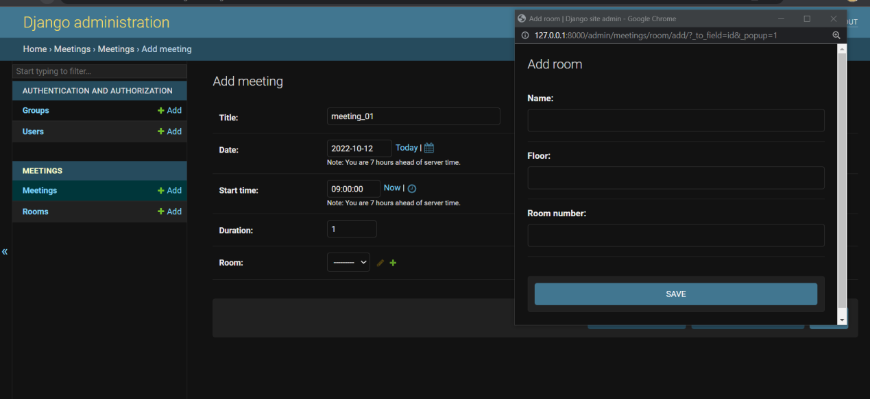

(note existing data will erase because we deleted that previous database)

You can notice Room filed is empty , click on that and add values.after adding the value check the rooms page

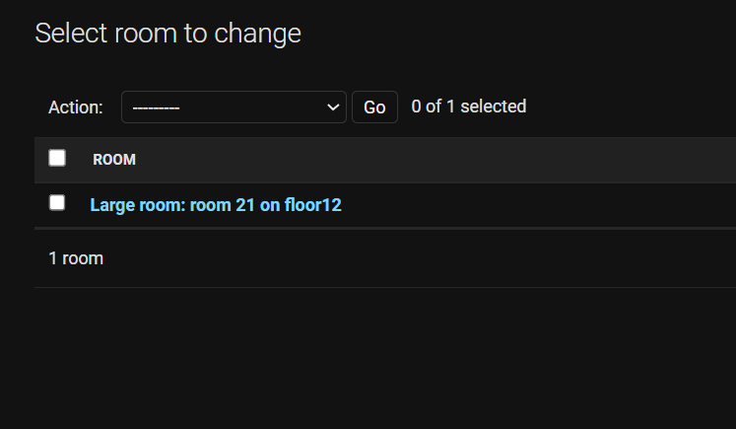

You can see some existing values is there because of meeting function.

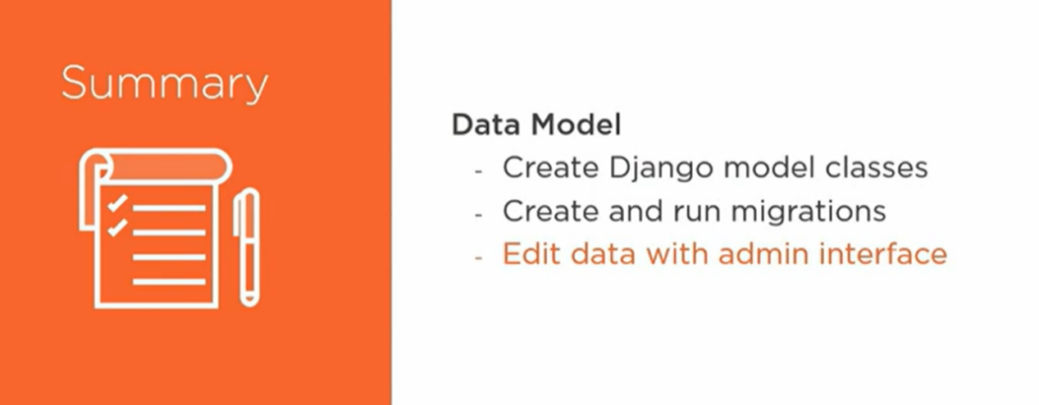

All set to done…

Let jump to another step:

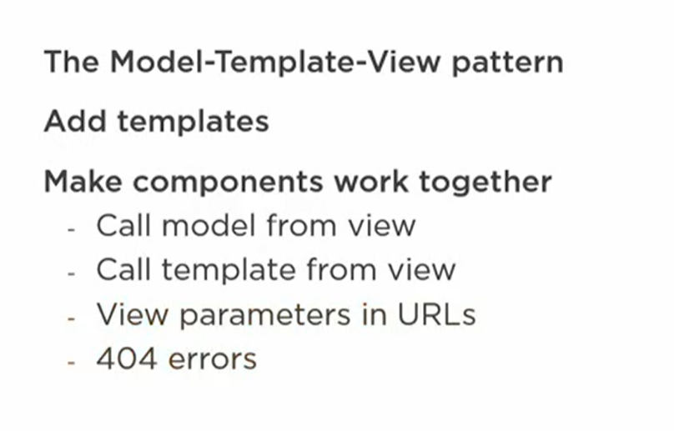

[note: Model View Template also known as Model View Controller]

Templates:

-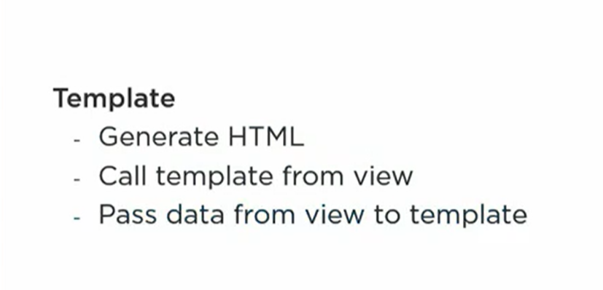

Templates are the components that are responsible for displaying our data to a user. In a web application, displaying data means creating a web page, so we'll use these templates to generate HTML that's the browser can display.

Lets create a folder called **templates** with in the website folder

create a folder called website with in the **templates**  folder

create new html file called **website.html**

**Folder structure:**

**website**

------ **templates**

------------------ **website**

----------------------------welcome.html

Add some components in welcome.html

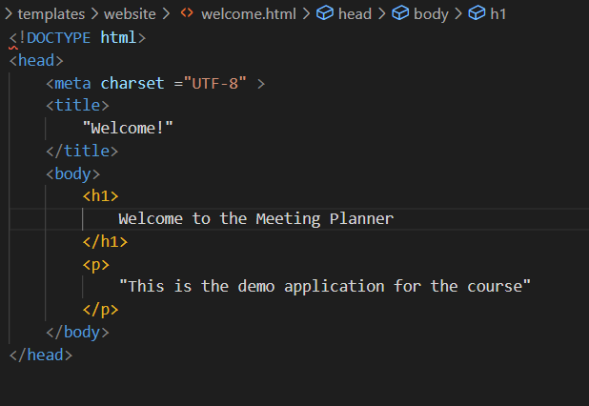

Once .html page is done then we need to modify our views.py files

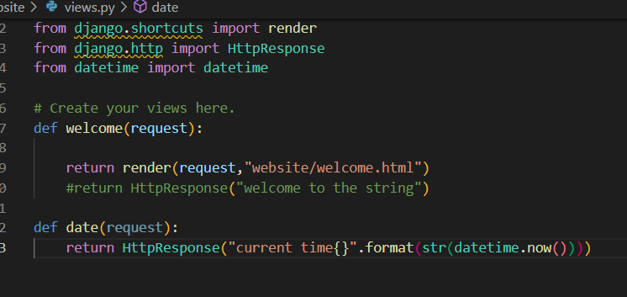

Request - This is an object that holds all kinds of information about the request that the browser sent, like cookies, HTTP headers, and more.

**Template variable and dynamic content**

Add a variable/placeholders in .html file. We add this anywhere in the file even in between tags is also fine.

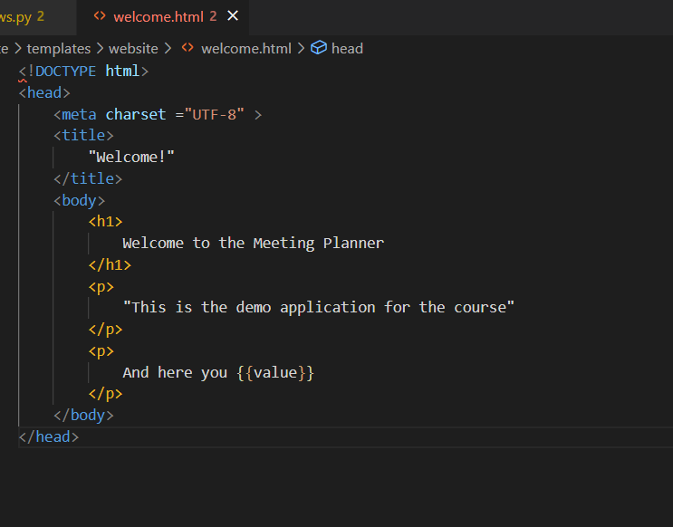

Let make changes in views.py

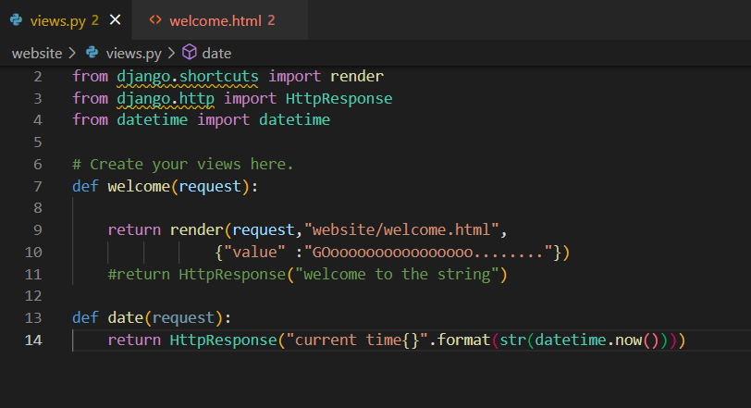

Note we need to pass variables and values in dict format.

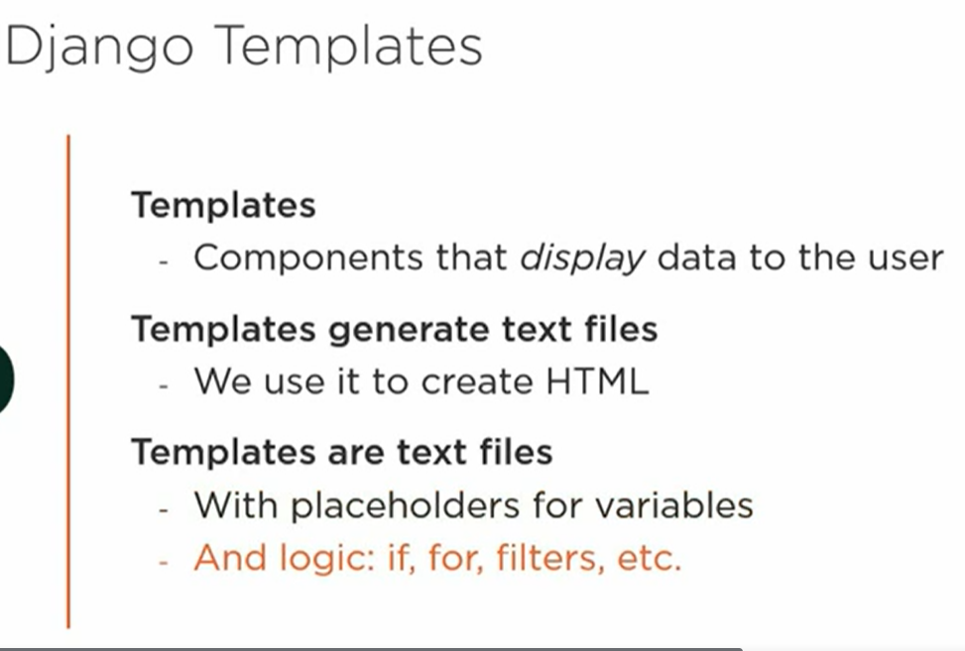

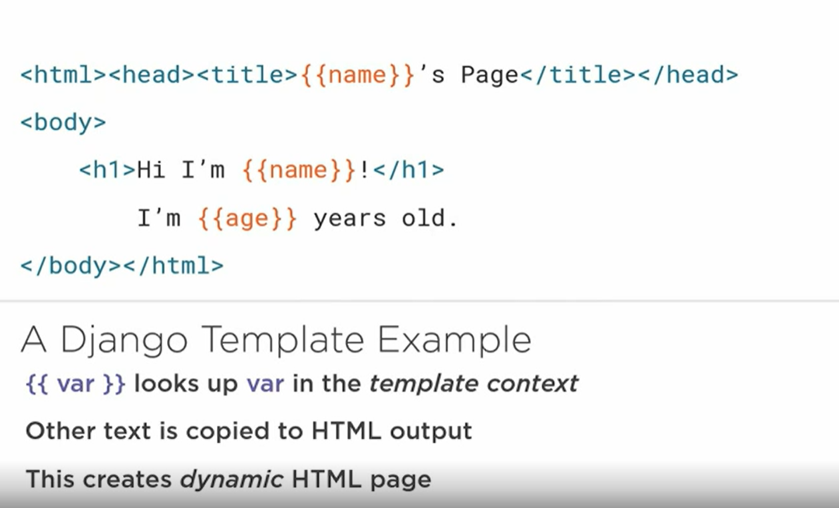

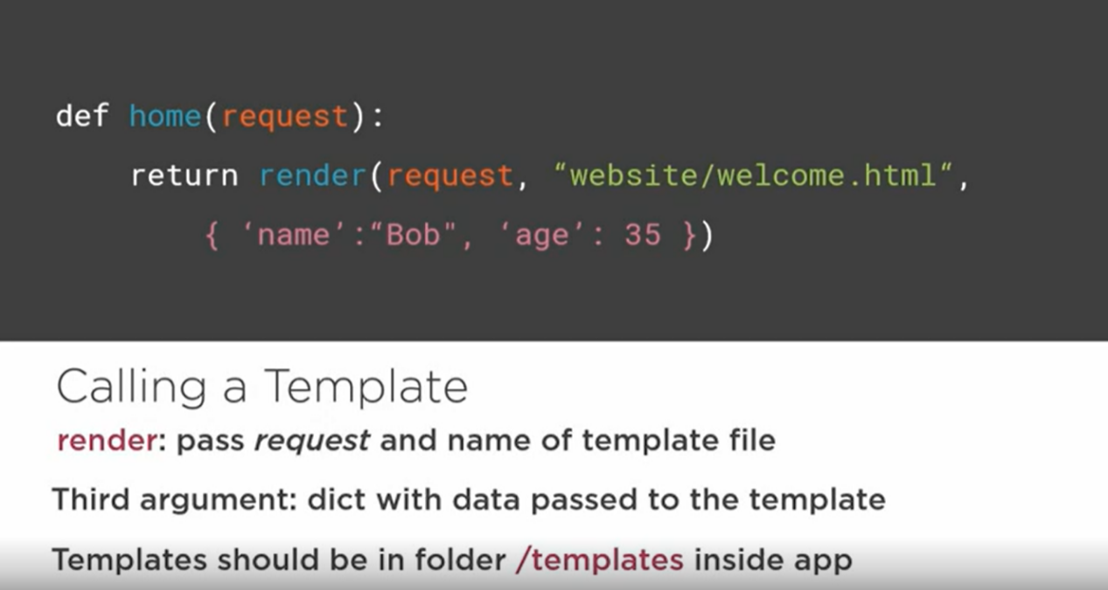

Lets see more about:

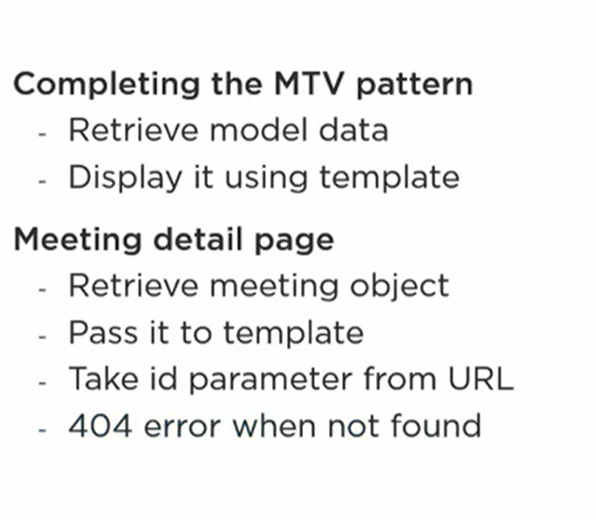

Let get data form Models.

Make changes in welcome.html file

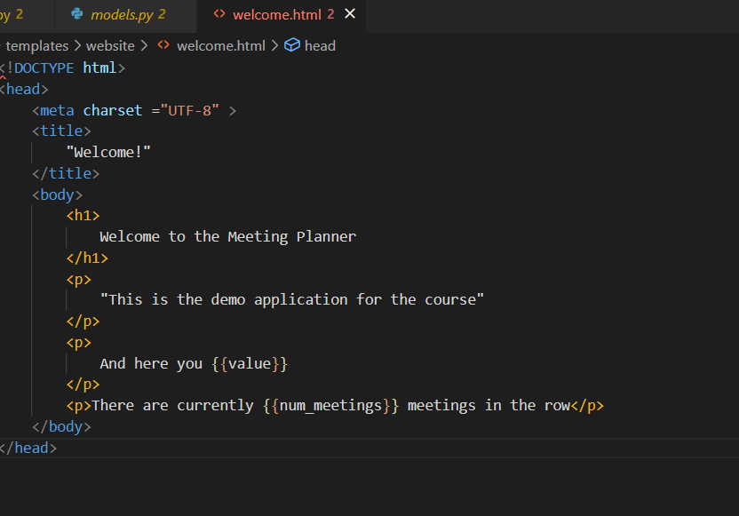

Views.py

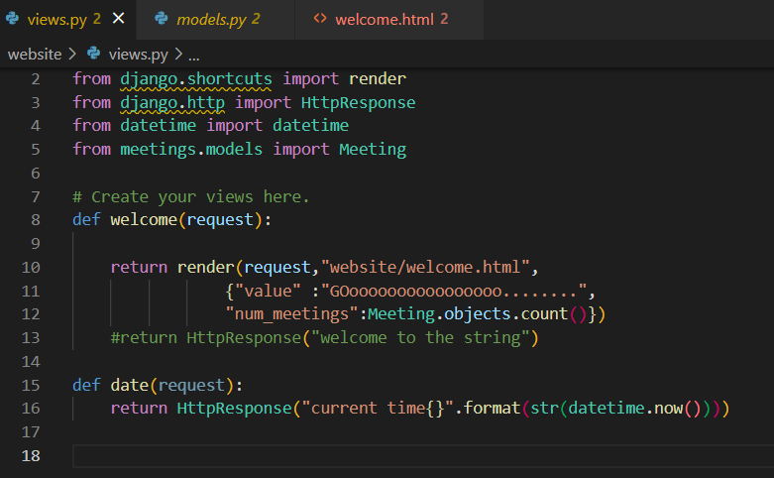

Import meeting model and apply it

**Taking Parameter from URL**

Lets add methods in views.py in meetings folder

**meetings/views.py**

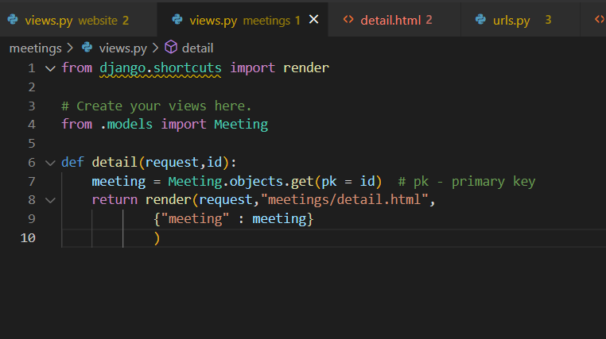

Then add this view into url.py

**meeting_planner/url.py**

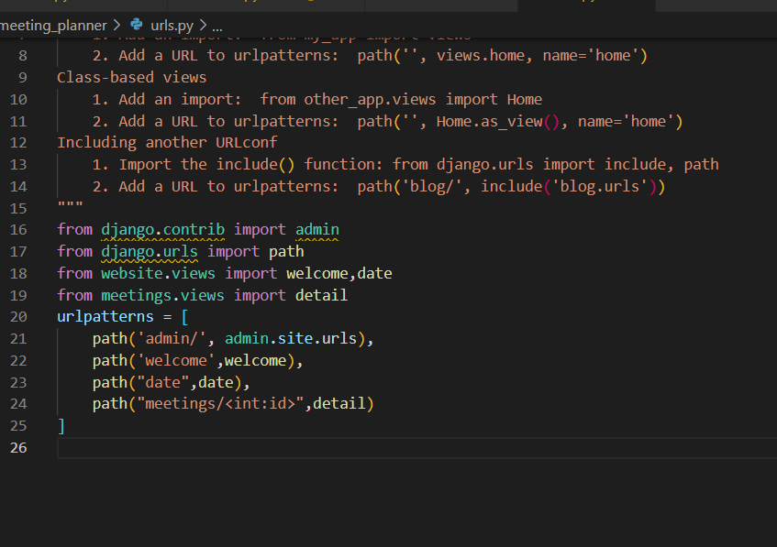

<int:var> representing input pattern

Now lets create the .html file in meetings folder

(folder structure)

meetings

-----------templates

--------------------meetings

------------------------detail.py

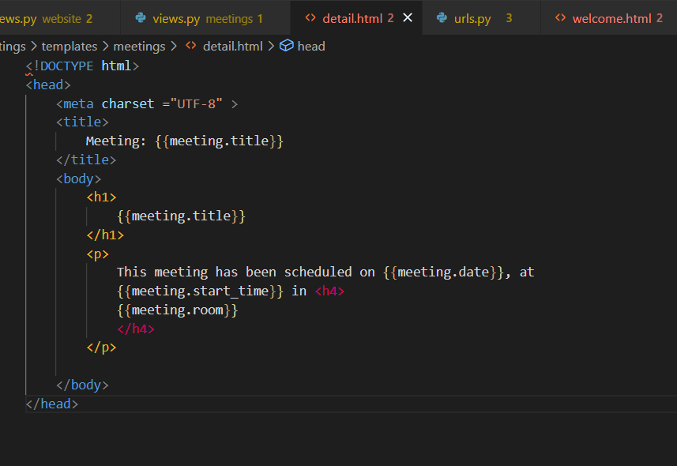

Now run the sever( python manage.py runserver) and access the url like

<http://127.0.0.1:8000/meetings/1>

Lets review what we got.

The Model-Template-View pattern makes up the core structure of a Django web application.

It consists of three types of components. They are

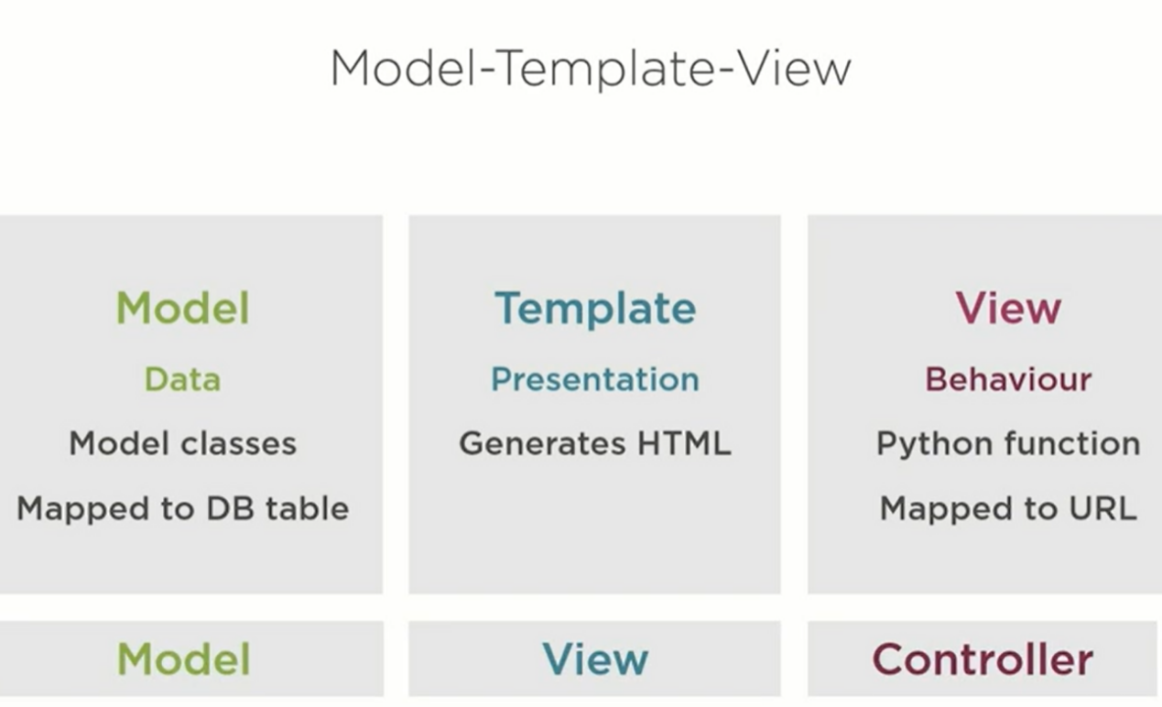

The view, which defines the behavior for a page. Its responsibility is to determine how to send the appropriate content to the client. The views we've seen so far are functions which we map to a URL using a pattern in urls.py.

The template has the responsibility to create a user friendly presentation, and it does so by generating an HTML page to be shown in the browser.

The model, which represents the data that lives in our application. In Django, we write model classes, which are mapped to database tables.

MTV Pattern

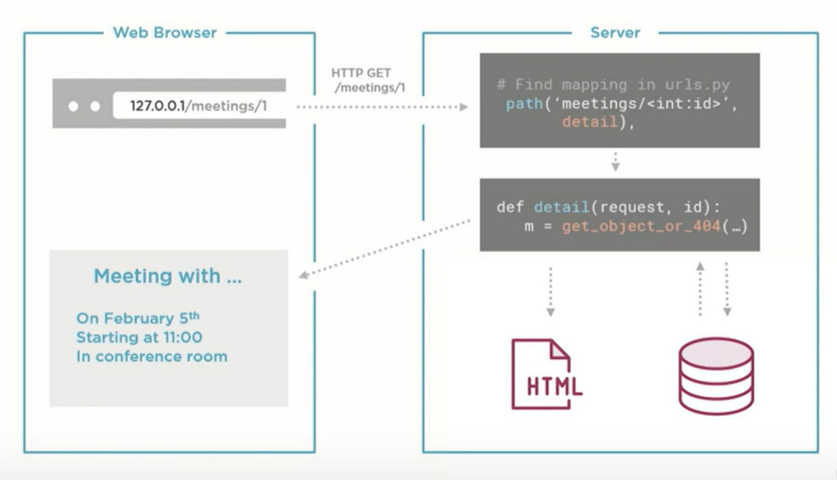

Lets see about:

* URL Building
* Named URLs
* For loop in template

For Loop in template:

Let make some modifications in **views.py**

**Meeting_planner**

**-------website**

**-------------views.py**

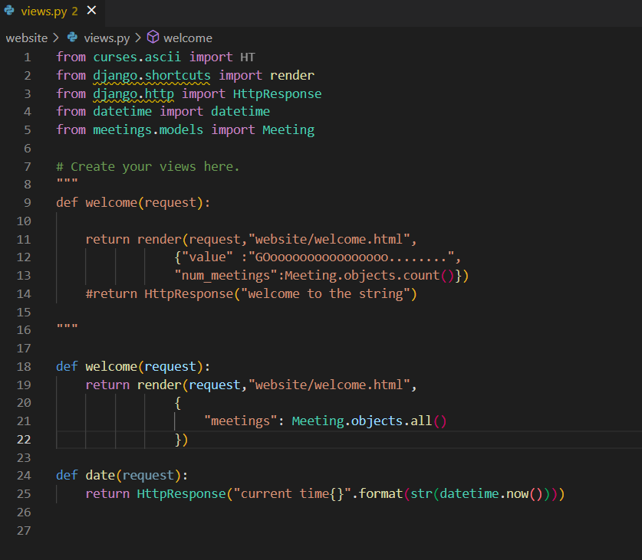

Now time to make changes in website.html

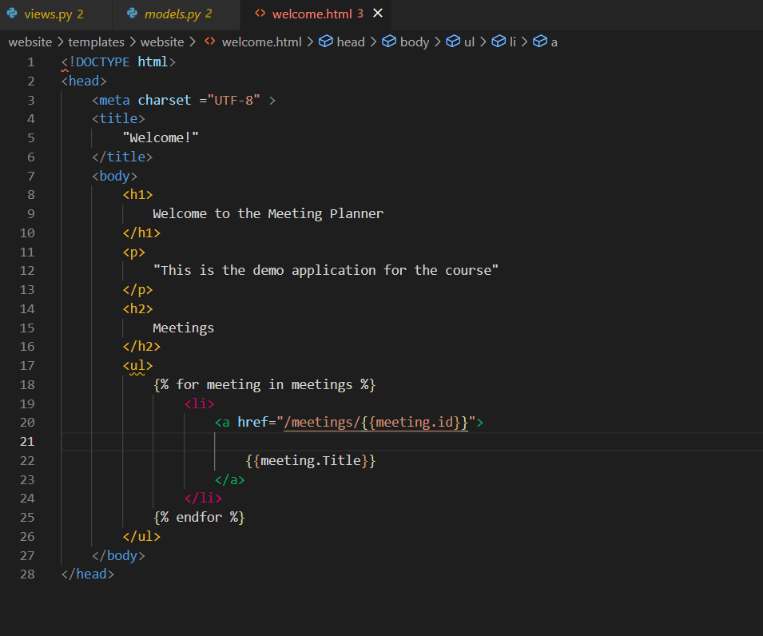

URL Binding/Link building :

Urls.py

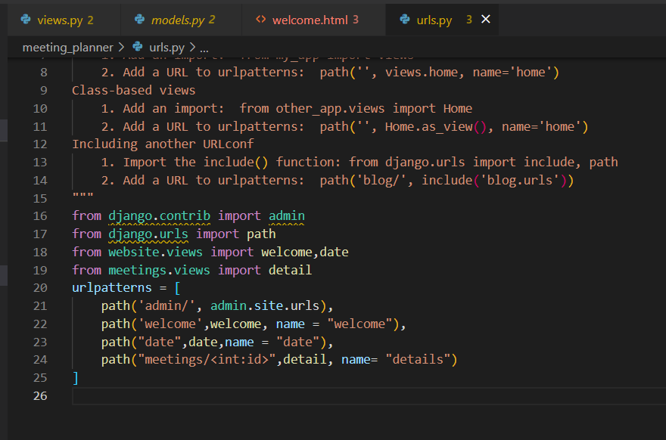

Django defines a special template tag called url, which looks up a specific URL mapping. We use a curly brace and percent sign to call it, and we pass the name of a specific URL mapping.

Views.html

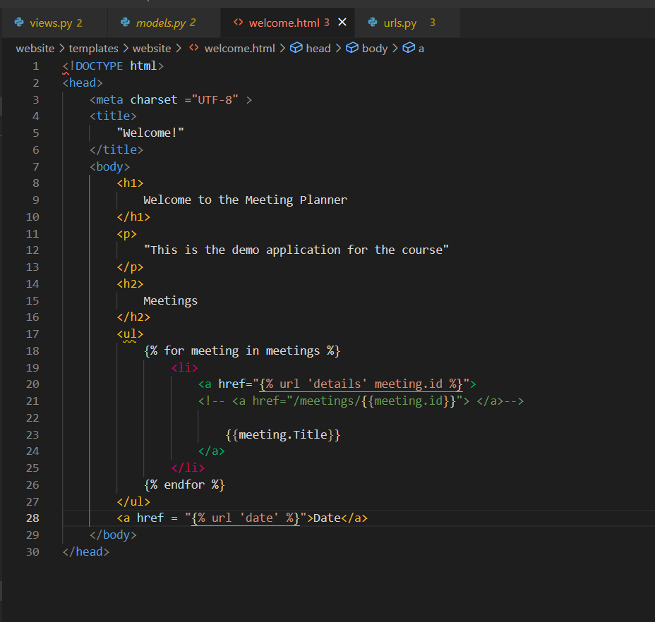

Best Pratice:

Add a urls.py inside our meetings app and change the main urls.py so that it includes the app's URL mappings and adds a prefix. That sounds kind of abstract,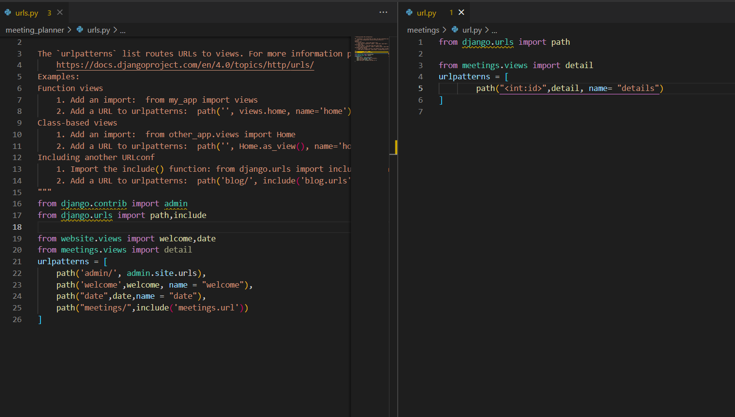

REVIEW:

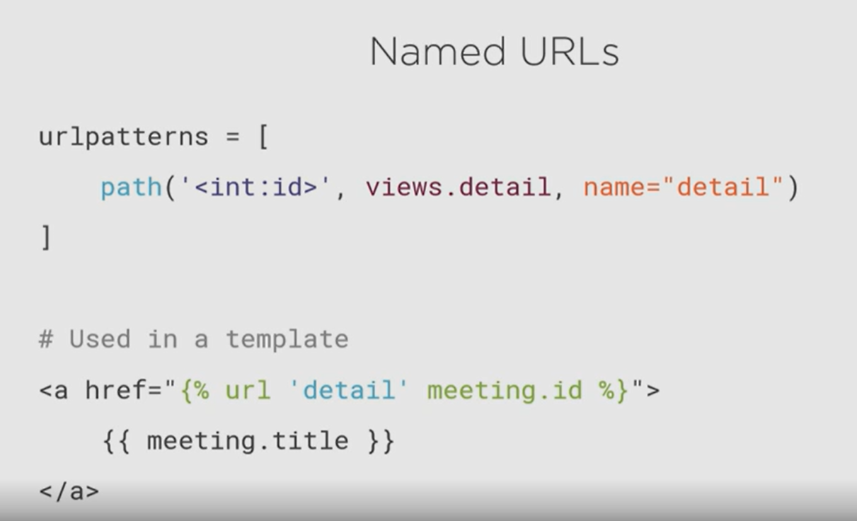

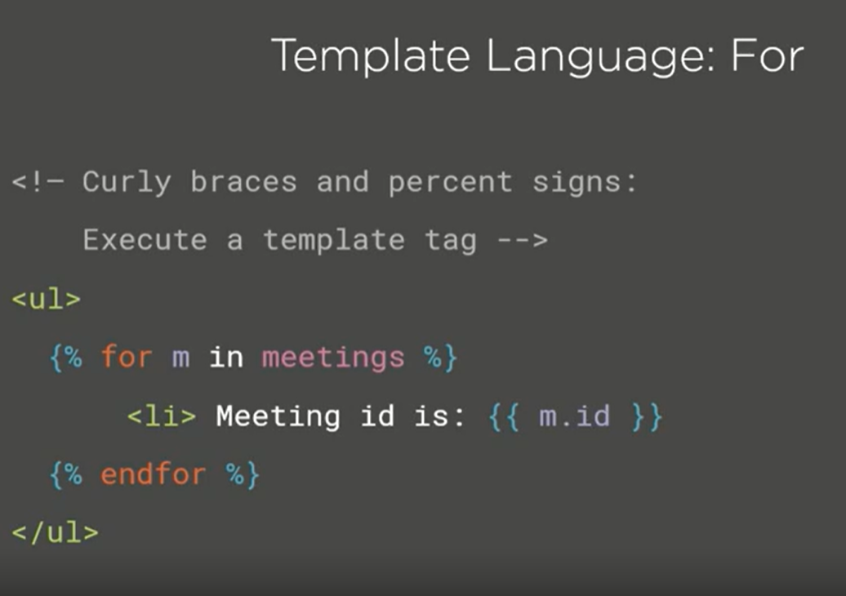

Best practice

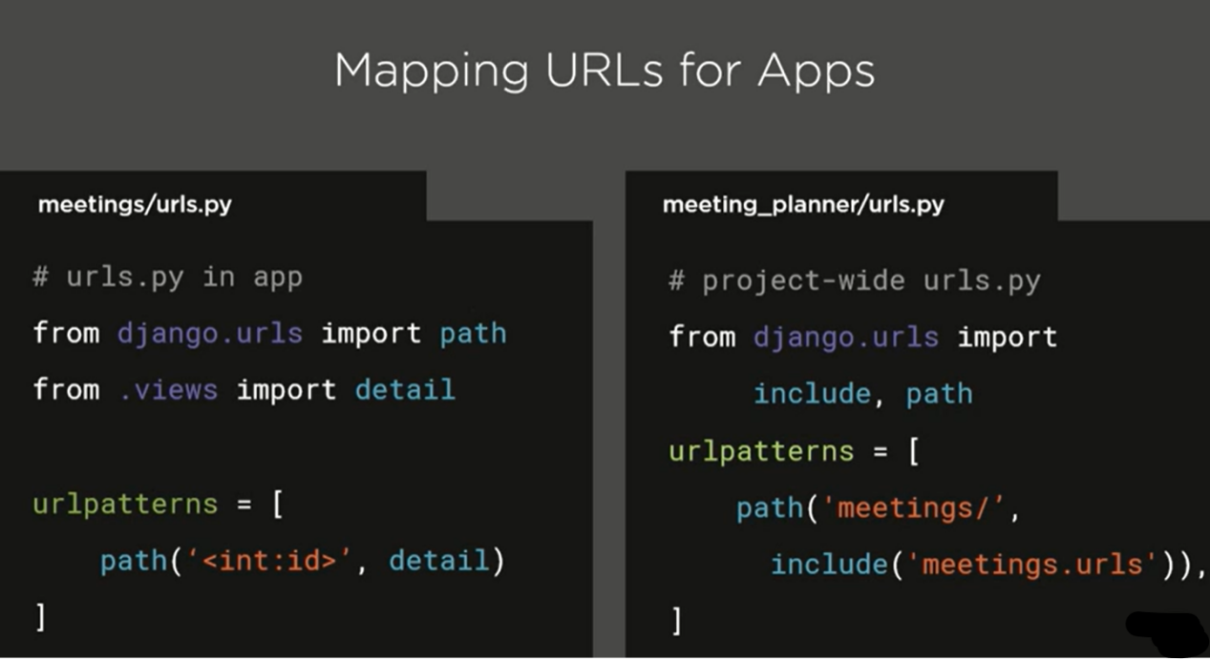

_-----------------------------------------------------------------------

Next Journey in Templates, Styling, Statics Content:

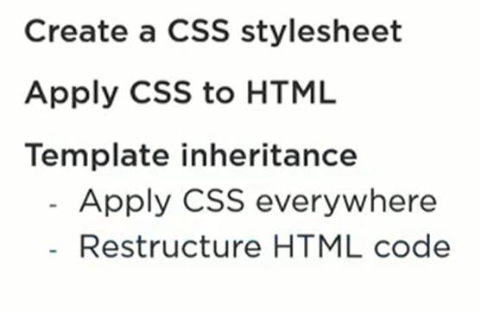

Let create a static folder in website folder

Folder structure.

website

----------static

--------------------website

------------------------------style.css

Add tags in style.css file

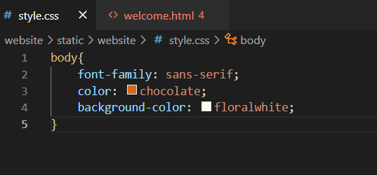

Now make changes in html file

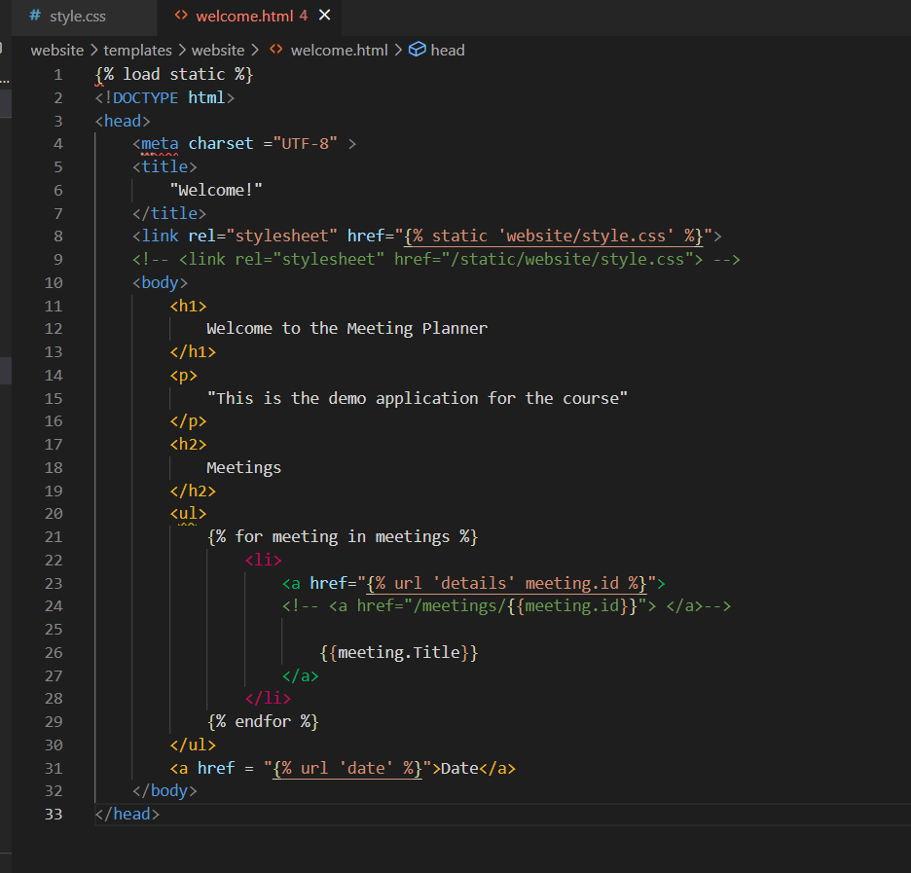

You can also Add image in the static folder itself

Save the image in static/website folder

Then in then html you can make modifications

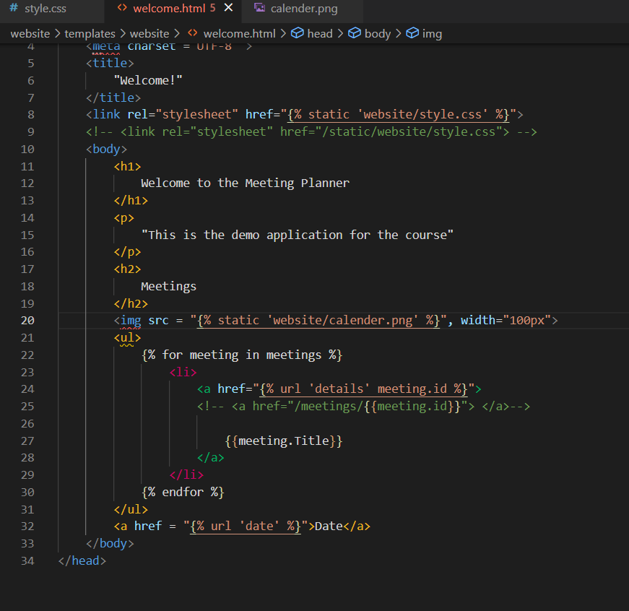

Template Inheritance

Let create a file called base.html in template folder. This file contain all the basic needs.

Website/template/base.html

Create base.html

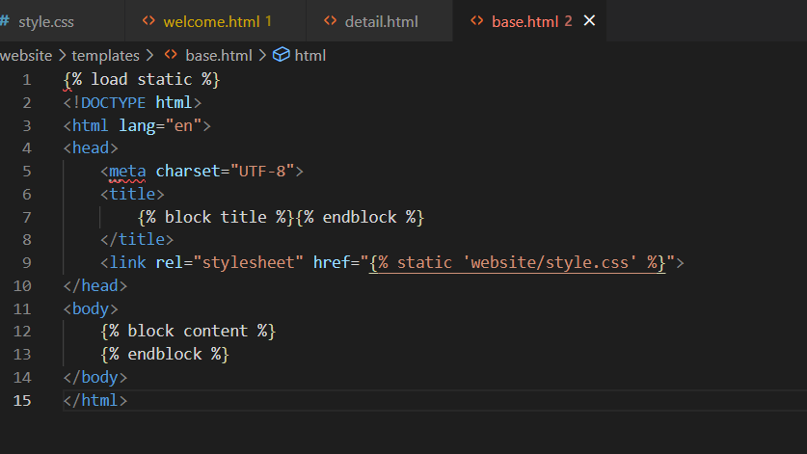

Make changes in welcome.html ( inherit the base.html file)

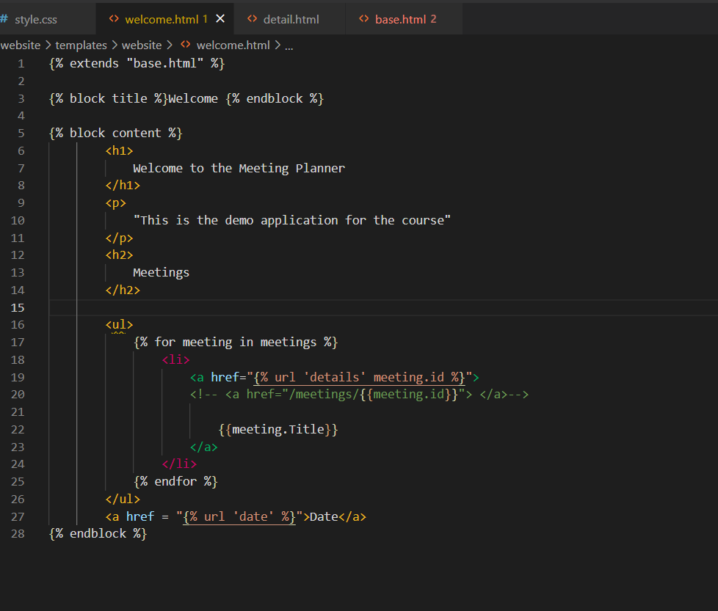

Similarly make changes in details.html

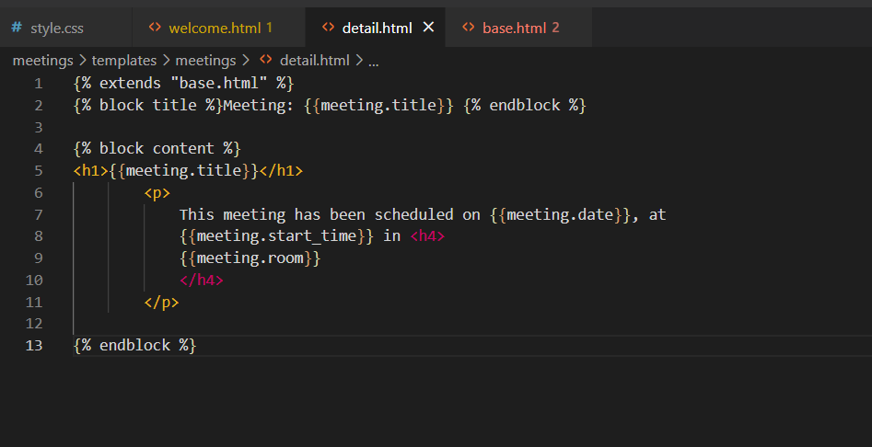now refresh the server.

REVIEW

